VISVESVARAYA TECHNOLOGICAL UNIVERSITY

“JnanaSangama”, Belgaum -590014, Karnataka.


LAB REPORT

On

ANALYSIS AND DESIGN OF ALGORITHMS (23CS4PCADA)

Submitted by

CCHIRANTH B S (1BM24CS077)

in partial fulfillment for the award of the degree of BACHELOR OF ENGINEERING
in
COMPUTER SCIENCE AND ENGINEERING


B.M.S. COLLEGE OF ENGINEERING
(Autonomous Institution under VTU) BENGALURU-560019
February 2026 to June 2026

CERTIFICATE
B. M. S. College of Engineering,
Bull Temple Road, Bangalore 560019
(Affiliated To Visvesvaraya Technological University, Belgaum) Department of Computer Science and Engineering



This is to certify that the Lab work entitled “ANALYSIS AND DESIGN OF ALGORITHMS” carried out by CCHIRANTH B S(1BM24CS077), who is a bonafide student of B. M. S. College of Engineering. It is in partial fulfillment for the award of Bachelor of Engineering in Computer Science and Engineering of the Visvesvaraya Technological University, Belgaum during the year 2025-26. The Lab report has been approved as it satisfies the academic requirements in respect of Analysis and Design of Algorithms Lab - (23CS4PCADA) work prescribed for the said degree.

Mrs Pallavi C V Dr. Kavitha Sooda
Assistant Professor Professor and Head
Department of CSE Department of CSE
BMSCE, Bengaluru BMSCE, Bengaluru

Index

Sl.  No. | Experiment Title | Page No.
1 | Write a program to obtain the Topological ordering of vertices in a given digraph. | 1 - 4
2 | Implement Johnson Trotter algorithm to generate permutations. | 5 - 6
3 | Sort a given set of N integer elements using Merge Sort technique and compute its time taken. Run the program for different values of N and record the time taken to sort. | 7 - 9
4 | Sort a given set of N integer elements using Quick Sort technique and compute its time taken. | 10 - 12
5 | Sort a given set of N integer elements using Heap Sort technique and compute its time taken. | 13 - 14
6 | Implement 0/1 Knapsack problem using dynamic programming. | 15 - 18
7 | Implement All Pair Shortest paths problem using Floyd’s algorithm. | 19 - 21
8 | - Find Minimum Cost Spanning Tree of a given undirected graph using Prim’s algorithm.  - Find Minimum Cost Spanning Tree of a given undirected graph using Kruskal’s algorithm. | 22 - 23  24 - 25
9 | Implement Fractional Knapsack using Greedy technique. | 26 - 27
10 | From a given vertex in a weighted connected graph, find shortest paths to other vertices using Dijkstra’s algorithm. | 28 - 29
11 | Implement “N-Queens Problem” using Backtracking. | 30 - 31

Course outcomes:

CO1 | Analyze time complexity of algorithms using asymptotic notations.
CO2 | Apply various algorithm design techniques for the given problem.
CO3 | Evaluate the appropriate algorithm/design technique for solving a given problem.
CO4 | Conduct practical experiments by applying appropriate algorithm design  technique to solve problems.

Lab program : LEETCODE - Container with most water
You are given an integer array height of length n. There are n vertical lines drawn such that the two endpoints of the i^{th} line are (i, 0) and (i, height[i]).
Find two lines that together with the x-axis form a container, such that the container contains the most water.
Return the maximum amount of water a container can store.
int maxArea(int* height, int heightSize) { int left = 0;
int right = heightSize - 1; int maxWater = 0;
while (left < right) {
height[rignhtt]h;= (height[left] < height[right]) ? height[left] : int width = right - left;
int area = h * width; if (area > maxWater)
maxWater = area;
if (height[left] < height[right]) left++;
else
right--;
}
return maxWater;
}

Output:
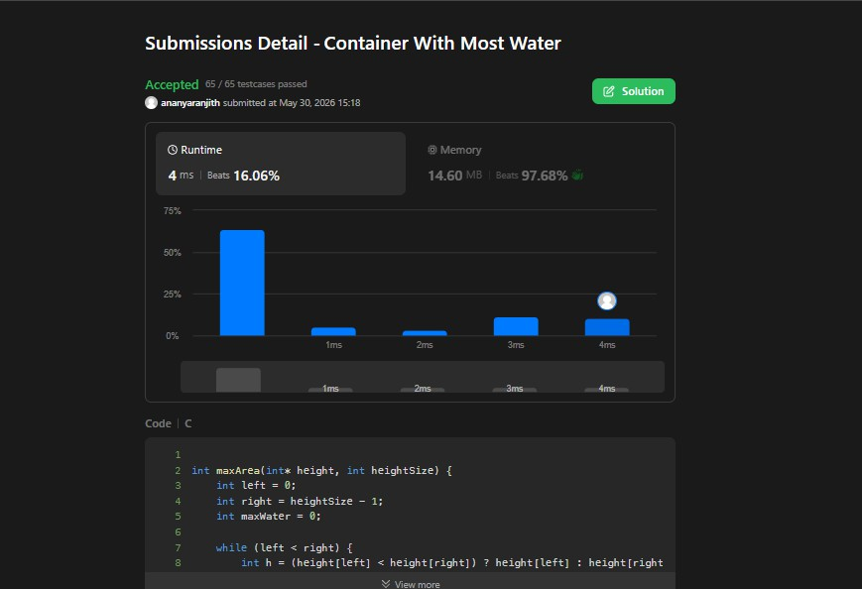

Lab program : LEETCODE - First and Last position of element in a sorted array
Given an array of integers nums sorted in non-decreasing order, find the starting and ending position of a given target value.
If the target is not found in the array, return [-1, -1].
int findFirst(int* nums, int numsSize, int target){ int left = 0, right = numsSize - 1;
int ans = -1;
while (left <= right) {
int mid = left + (right - left) / 2; if (nums[mid] == target) {
ans = mid; right = mid - 1;
} else if (nums[mid] < target) { left = mid + 1;
} else {
right = mid - 1;
}
}
return ans;
}
int findLast(int* nums, int numsSize, int target) { int left = 0, right = numsSize - 1;
int ans = -1;
while (left <= right) {
int mid = left + (right - left) / 2; if (nums[mid] == target) {
ans = mid; left = mid + 1;
} else if (nums[mid] < target) { left = mid + 1;
} else {
right = mid - 1;
}
}
return ans;
}
int* searchRange(int* nums, int numsSize, int target, int* returnSize) {
*returnSize = 2;
int* result = (int*)malloc(2 * sizeof(int)); result[0] = findFirst(nums, numsSize, target); result[1] = findLast(nums, numsSize, target);

return result;
}

Output:
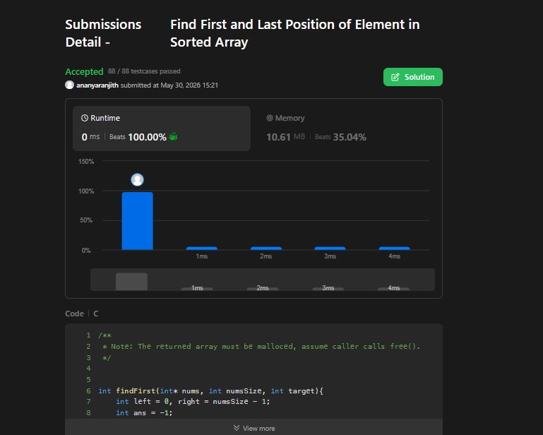

Lab program 1:
Write a program to obtain the Topological ordering of vertices in a given digraph.
#include <stdio.h> #define MAX 100 int main() {
int n, graph[MAX][MAX]; int indegree[MAX] = {0}; int visited[MAX] = {0};
printf("Enter number of vertices: "); scanf("%d", &n);
printf("Enter adjacency matrix:\n"); for (int i = 0; i < n; i++) {
for (int j = 0; j < n; j++) { scanf("%d", &graph[i][j]);
}
}
for (int i = 0; i < n; i++) { for (int j = 0; j < n; j++) {
if (graph[i][j] == 1) indegree[j]++;
}
}
printf("Topological Order: ");
for (int count = 0; count < n; count++) { int found = -1;
for (int i = 0; i < n; i++) {
if (indegree[i] == 0 && visited[i] == 0) { found = i;
break;
}
}
if (found == -1) {
printf("\nGraph has a cycle! No topological sort possible.\n"); return 0;
}
printf("%d ", found); visited[found] = 1;
for (int j = 0; j < n; j++) {
if (graph[found][j] == 1) indegree[j]--;
}

}
printf("\n"); return 0;
}

Output:
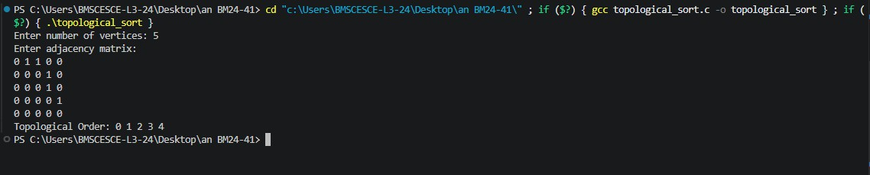

Graph:

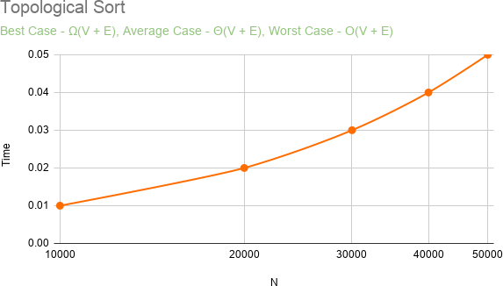

Lab program 4: LEETCODE - Course Schedule
There are a total of numCourses courses you have to take, labeled from 0 to numCourses - 1. You are given an array prerequisites where prerequisites[i] = [a_{i}, b_{i}] indicates that you must take course b_{i} first if you want to take course a_{i}.
For example, the pair [0, 1], indicates that to take course 0 you have to first take course 1. Return true if you can finish all courses. Otherwise, return false.

bool canFinish(int numCourses, int** prerequisites, int prerequisitesSize, int* prerequisitesColSize) {
int* indegree = (int*)calloc(numCourses, sizeof(int)); int** graph = (int**)malloc(numCourses * sizeof(int*)); int* graphSize = (int*)calloc(numCourses, sizeof(int)); for (int i = 0; i < numCourses; i++) {
graph[i] = (int*)malloc(prerequisitesSize * sizeof(int));
}
for (int i = 0; i < prerequisitesSize; i++) { int course = prerequisites[i][0];
int prereq = prerequisites[i][1];

graph[prereq][graphSize[prereq]++] = course; indegree[course]++;
}
int* queue = (int*)malloc(numCourses * sizeof(int)); int front = 0, rear = 0;
for (int i = 0; i < numCourses; i++) { if (indegree[i] == 0)
queue[rear++] = i;
}
int completed = 0; while (front < rear) {
int curr = queue[front++]; completed++;
for (int i = 0; i < graphSize[curr]; i++) { int next = graph[curr][i]; indegree[next]--;
if (indegree[next] == 0) queue[rear++] = next;
}
}
free(indegree); free(queue);

free(graphSize);
for (int i = 0; i < numCourses; i++) free(graph[i]);
free(graph);
return completed == numCourses;
}

Output:
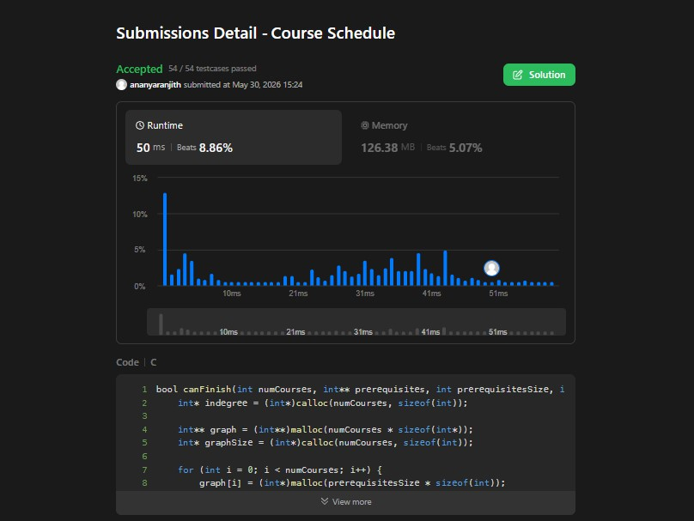

Lab program 2:
Implement Johnson Trotter algorithm to generate permutations.

#include <stdio.h>
int getMobile(int a[], int dir[], int n)
{
int mobile = 0, mobile_index = -1; for (int i = 0; i < n; i++)
{
if (dir[a[i]] == -1 && i != 0 && a[i] > a[i-1] && a[i] > mobile)
{
mobile = a[i]; mobile_index = i;
}
if (dir[a[i]] == 1 && i != n-1 && a[i] > a[i+1] && a[i] > mobile)
{
mobile = a[i]; mobile_index = i;
}
}
return mobile_index;
}
void printPermutation(int a[], int n)
{
for (int i = 0; i < n; i++) printf("%d ", a[i]);
printf("\n");
}
void johnsonTrotter(int n)
{
int a[n], dir[n+1];
for (int i = 0; i < n; i++) a[i] = i + 1;
for (int i = 1; i <= n; i++)
dir[i] = -1; // -1 = left, 1 = right printPermutation(a, n);
while (1)
{
int mobile_index = getMobile(a, dir, n);

if (mobile_index == -1) break;
int mobile = a[mobile_index];
int swap_index = mobile_index + dir[mobile]; int temp = a[mobile_index];
a[mobile_index] = a[swap_index]; a[swap_index] = temp; mobile_index = swap_index;
for (int i = 0; i < n; i++)
{
if (a[i] > mobile) dir[a[i]] = -dir[a[i]];
}
printPermutation(a, n);
}
}
int main()
{
int n;
printf("Enter number of elements: "); scanf("%d", &n);
johnsonTrotter(n); return 0;
}

Output:
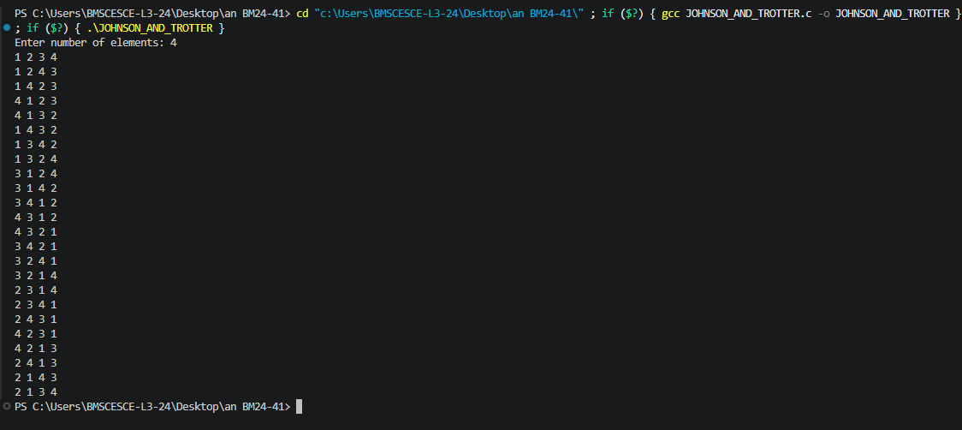

Lab program 3:
Sort a given set of N integer elements using Merge Sort technique and compute its time taken. Run the program for different values of N and record the time taken to sort.

#include <stdio.h>
void merge(int arr[], int left, int mid, int right)
{
int n1 = mid - left + 1; int n2 = right - mid; int L[n1], R[n2];
for(int i = 0; i < n1; i++) L[i] = arr[left + i]; for(int j = 0; j < n2; j++)
R[j] = arr[mid + 1 + j];

int i = 0, j = 0, k = left; while(i < n1 && j < n2)
{
if(L[i] <= R[j])
{
arr[k] = L[i]; i++;
}
else
{
arr[k] = R[j]; j++;
}
k++;
}
while(i < n1)
{
arr[k] = L[i]; i++;
k++;
}
while(j < n2)
{
arr[k] = R[j]; j++;

k++;
}
}
void mergeSort(int arr[], int left, int right)
{
if(left < right)
{
int mid = left + (right - left) / 2; mergeSort(arr, left, mid); mergeSort(arr, mid + 1, right); merge(arr, left, mid, right);
}
}
void printArray(int arr[], int size)
{
for(int i = 0; i < size; i++) printf("%d ", arr[i]);

printf("\n");
}
int main()
{
int arr[] = {38, 27, 43, 10};
int n = sizeof(arr) / sizeof(arr[0]); printf("Original array:\n"); printArray(arr, n);
mergeSort(arr, 0, n - 1); printf("Sorted array:\n"); printArray(arr, n);
return 0;
}

Output:
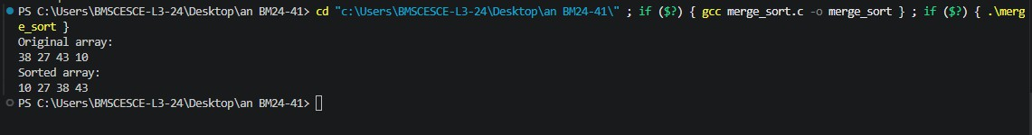

Graph:

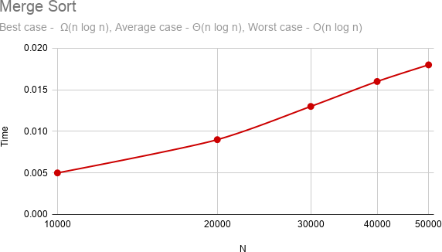

Lab program 4:
Sort a given set of N integer elements using Quick Sort technique and compute its time taken.

#include <stdio.h>
void swap(int *a, int *b)
{
int temp = *a;
*a = *b;
*b = temp;
}
int partition(int arr[], int low, int high)
{
int pivot = arr[high]; int i = low - 1;
for(int j = low; j < high; j++)
{
if(arr[j] < pivot)
{
i++;
swap(&arr[i], &arr[j]);
}
}
swap(&arr[i + 1], &arr[high]); return i + 1;
}
void quickSort(int arr[], int low, int high)
{
if(low < high)
{
int pi = partition(arr, low, high); quickSort(arr, low, pi - 1); quickSort(arr, pi + 1, high);
}
}
void printArray(int arr[], int n)
{
for(int i = 0; i < n; i++)
{
printf("%d ", arr[i]);

}
printf("\n");
}
int main()
{
int arr[] = {38, 27, 43, 10, 9, 82};
int n = sizeof(arr) / sizeof(arr[0]); printf("Original Array:\n"); printArray(arr, n);
quickSort(arr, 0, n - 1); printf("Sorted Array:\n"); printArray(arr, n);
return 0;
}

Output:
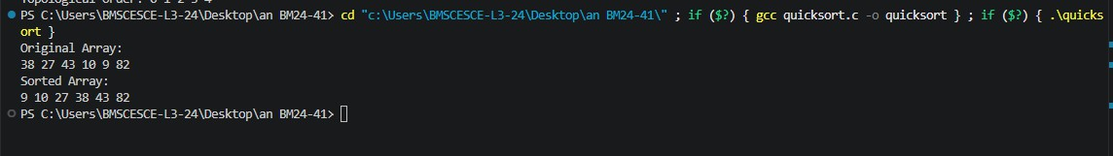

Graph:

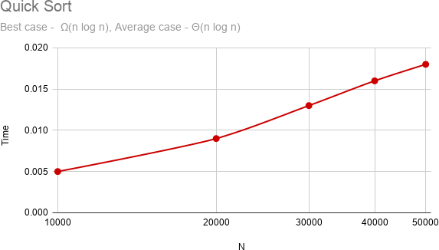

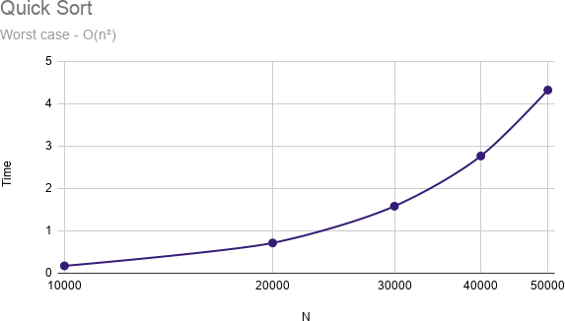

Lab program 5:
Sort a given set of N integer elements using Heap Sort technique and compute its time taken.

#include <stdio.h>
void heapify(int arr[], int n, int i) { int largest = i;
int left = 2 * i + 1; int right = 2 * i + 2;
if (left < n && arr[left] > arr[largest]) largest = left;
if (right < n && arr[right] > arr[largest]) largest = right;
if (largest != i) { int temp = arr[i];
arr[i] = arr[largest]; arr[largest] = temp; heapify(arr, n, largest);
}
}
void heapSort(int arr[], int n) { for (int i = n / 2 - 1; i >= 0; i--)
heapify(arr, n, i);
for (int i = n - 1; i > 0; i--) { int temp = arr[0];
arr[0] = arr[i]; arr[i] = temp; heapify(arr, i, 0);
}
}
int main(){ int n;
printf("Enter the number of elements: "); scanf("%d", &n);
int arr[n];
printf("Enter the elements: "); for(int i = 0; i < n; i++){
scanf("%d", &arr[i]);
}
heapSort(arr, n);

printf("Sorted array: "); for(int i = 0; i < n; i++){ printf("%d ", arr[i]);
}
printf("\n"); return 0;
}

Output:
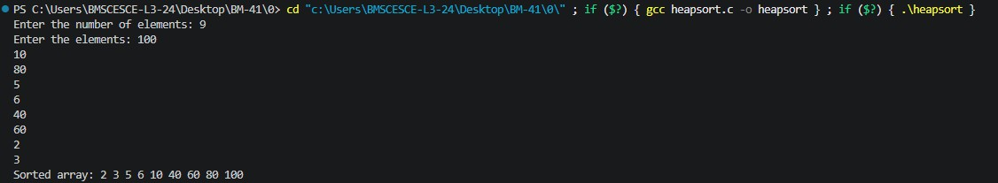

Graph:

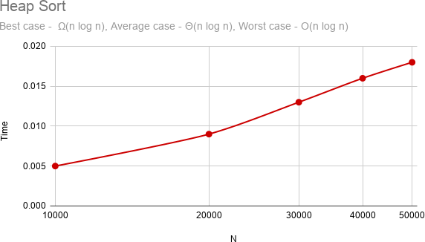

Lab program 6:
Implement 0/1 Knapsack problem using dynamic programming.

#include<stdio.h>
int n,m,w[10],p[10],v[20][20];
int max(int a,int b){ return (a>b)?a:b;
}
void knapsack(int n, int m, int w[],int p[]){ int i,j;
for(i=0;i<=n;i++){ for(j=0;j<=m;j++){
if(i==0 || j==0){ v[i][j]=0;
}
else if(w[i-1] > j){ v[i][j]=v[i-1][j];
}
else{
v[i][j]=max(v[i-1][j],
p[i-1] + v[i-1][j - w[i-1]]);
}
}
}
}
int main(){ int i,j;
printf("Enter number of items: "); scanf("%d",&n);
printf("Enter capacity: "); scanf("%d",&m); printf("Enter weights:\n"); for(i=0;i<n;i++)
scanf("%d",&w[i]); printf("Enter profits:\n"); for(i=0;i<n;i++)
scanf("%d",&p[i]);
knapsack(n,m,w,p); printf("\nDP Table:\n"); for(i=0;i<=n;i++){

for(j=0;j<=m;j++){ printf("%d ",v[i][j]);
}
printf("\n");
}
printf("\nMaximum Profit = %d\n", v[n][m]); return 0;
}

Output:
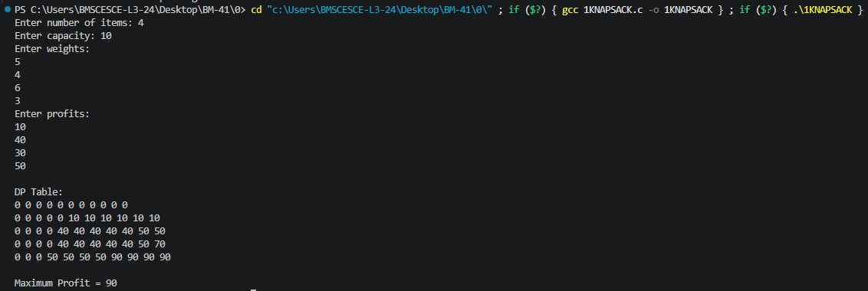

Lab program 6: LEETCODE -Minimum Swaps to make Sequences Increasing
You are given two integer arrays of the same length nums1 and nums2. In one operation, you are allowed to swap nums1[i] with nums2[i].
For example, if nums1 = [1,2,3,8], and nums2 = [5,6,7,4], you can swap the element at i = 3 to obtain nums1 = [1,2,3,4] and nums2 = [5,6,7,8].
Return the minimum number of needed operations to make nums1 and nums2 strictly increasing. The test cases are generated so that the given input always makes it possible.
An array arr is strictly increasing if and only if arr[0] < arr[1] < arr[2] < ... < arr[arr.length - 1].

#include <limits.h> int min(int a, int b) {
return a < b ? a : b;
}
int minSwap(int* nums1, int nums1Size, int* nums2, int nums2Size) { int keep = 0;
int swap = 1;
for (int i = 1; i < nums1Size; i++) { int newKeep = INT_MAX;
int newSwap = INT_MAX;
if (nums1[i] > nums1[i - 1] && nums2[i] > nums2[i - 1]) { newKeep = min(newKeep, keep); newSwap = min(newSwap, swap + 1);
}
if (nums1[i] > nums2[i - 1] && nums2[i] > nums1[i - 1]) { newKeep = min(newKeep, swap); newSwap = min(newSwap, keep + 1);
}
keep = newKeep; swap = newSwap;
}
return min(keep, swap);
}

Output:
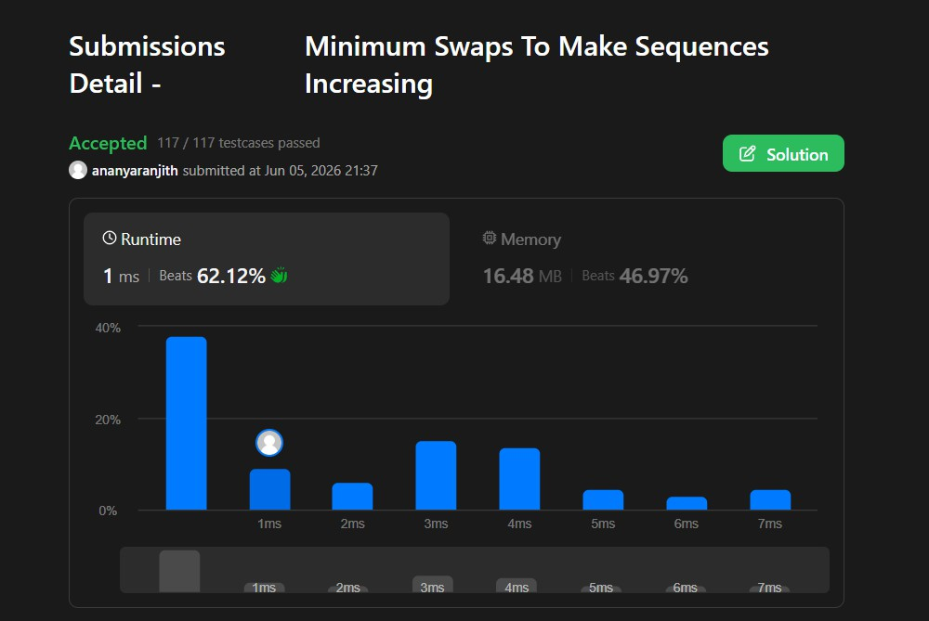

Lab program 7:
Implement All Pair Shortest paths problem using Floyd’s algorithm.

#include <stdio.h>
int a[10][10], D[10][10], n;
void floyd(int a[][10], int n); int min(int a, int b);
int main() { int i, j;
printf("Enter the number of vertices: "); scanf("%d", &n);
printf("Enter the cost adjacency matrix:\n"); for(i = 0; i < n; i++) {
for(j = 0; j < n; j++) { scanf("%d", &a[i][j]);
}
}
floyd(a, n);
printf("Distance Matrix:\n"); for(i = 0; i < n; i++) {
for(j = 0; j < n; j++) { printf("%d ", D[i][j]);
}
printf("\n");
}
return 0;
}
void floyd(int a[][10], int n) { int i, j, k;
for(i = 0; i < n; i++) { for(j = 0; j < n; j++) {
D[i][j] = a[i][j];
}
}
for(k = 0; k < n; k++) { for(i = 0; i < n; i++) {
for(j = 0; j < n; j++) {
D[i][j] = min(D[i][j], D[i][k] + D[k][j]);
}
}

}
}

int min(int a, int b) { if(a < b)
return a; else
return b;
}

Output:
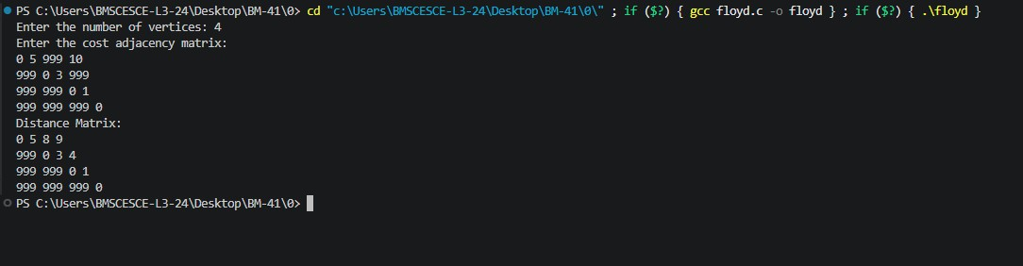

Lab program 7: LEETCODE - Find the duplicate number
Given an array of integers nums containing n + 1 integers where each integer is in the range [1, n] inclusive.
There is only one repeated number in nums, return this repeated number.
int findDuplicate(int* nums, int numsSize) { int slow = nums[0];
int fast = nums[0]; do {
slow = nums[slow];
fast = nums[nums[fast]];
} while (slow != fast); slow = nums[0];
while (slow != fast) { slow = nums[slow]; fast = nums[fast];
}
return slow;
}

Output:
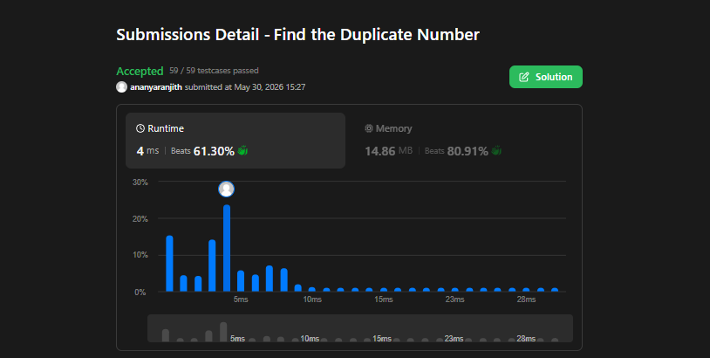

Lab program 8a:
Find Minimum Cost Spanning Tree of a given undirected graph using Prim’s algorithm.

#include<stdio.h>
int cost[10][10], n, t[10][2], sum; void prims(int cost[10][10], int n); int main(){
int i, j;
printf("Enter number of vertices: "); scanf("%d", &n);
printf("Enter cost matrix:\n"); for(i=0; i<n; i++){
for(j=0; j<n; j++){ scanf("%d", &cost[i][j]);
}
}
prims(cost, n);
printf("Edges in the Minimum Spanning Tree:\n"); for(i=0; i<n-1; i++){
printf("%d %d\n", t[i][0], t[i][1]);
}
printf("Total cost of the Minimum Spanning Tree: %d\n", sum); return 0;
}
void prims(int cost[10][10], int n){ int i, j, u, v;
int min, source;
int p[10], d[10], s[10];
min=999; source=0;
for(i=0; i<n; i++){ p[i]=source; d[i]=cost[source][i]; s[i]=0;
}
s[source]=1; sum=0;
int k=0;
for(i=0; i<n-1; i++){ min=999;

u=-1;
for(j=0; j<n; j++){ if(s[j]==0 && d[j]<min){
min=d[j]; u=j;
}
}
if (u!=-1){
t[k][0]=u;
t[k][1]=p[u];
sum+=cost[u][p[u]]; k++;
s[u]=1;
for(v=0; v<n; v++){
if(s[v]==0 && cost[u][v]<d[v]){ p[v]=u;
d[v]=cost[u][v];
}
}
}
}}

Output:
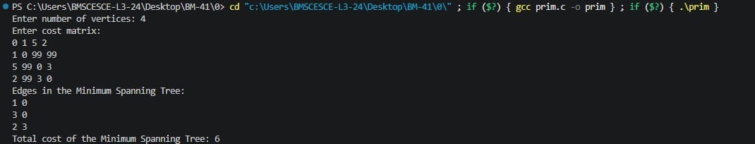

Lab program 8b:
Find Minimum Cost Spanning Tree of a given undirected graph using Kruskal’s algorithm.
#include<stdio.h>
int cost[10][10], n, t[10][2], sum; void kruskal(int cost[10][10], int n); int find(int parent[10], int i);
int main(){ int i, j;
printf("Enter the number of vertices: "); scanf("%d", &n);
printf("Enter the cost matrix:\n"); for(i=0; i<n; i++){
for(j=0; j<n; j++){ scanf("%d", &cost[i][j]);
}
}
kruskal(cost, n);
printf("Edges in the Minimum Spanning Tree:\n"); for(i=0; i<n-1; i++){
printf("%d %d\n", t[i][0], t[i][1]);
}
printf("Total cost of the Minimum Spanning Tree: %d\n", sum); return 0;
}
void kruskal(int cost[10][10], int n){ int min, u, v, count, k;
int parent[10]; int i, j;
k = 0;
sum = 0;
for(i=0; i<n; i++){ parent[i] = i;
}
count = 0; while(count < n-1){
min = 999; for(i=0; i<n; i++){
for(j=0; j<n; j++){
if(cost[i][j] != 0 && cost[i][j] < min){ min = cost[i][j];

u = i; v = j;
}
}
}
int root_u = find(parent, u); int root_v = find(parent, v); if(root_u != root_v){
t[k][0] = u;
t[k][1] = v; sum += min;
parent[root_v] = root_u; k++;
count++;
}
cost[u][v] = cost[v][u] = 999;
}
}
int find(int parent[10], int i){ while(parent[i] != i){
i = parent[i];
}
return i;
}

Output:
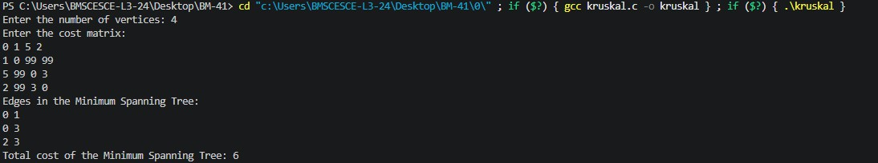

Lab program 9:
Implement fractional knapsack problem using Greedy technique.

#include<stdio.h> struct Item{
int weight; int profit; float ratio;
};
void swap(struct Item *a, struct Item *b){ struct Item temp=*a;
*a=*b;
*b=temp;
}
void sortItems(struct Item arr[], int n){ for(int i=0; i<n-1; i++){
for(int j=0; j<n-i-1; j++){ if(arr[j].ratio < arr[j+1].ratio){
swap(&arr[j], &arr[j+1]);
}
}
}
}
float fk(struct Item arr[], int n, int capacity){ float totalProfit=0.0;
for(int i=0; i<n; i++){ if(capacity >= arr[i].weight){
totalProfit += arr[i].profit; capacity -= arr[i].weight;
}else{
totalProfit += arr[i].ratio * capacity; break;
}
}
return totalProfit;
}
int main(){
int n, capacity;
printf("Enter number of items: "); scanf("%d", &n);

struct Item arr[n];
printf("Enter weight and profit of each item:\n"); for(int i=0; i<n; i++){
scanf("%d %d", &arr[i].weight, &arr[i].profit); arr[i].ratio = (float)arr[i].profit / arr[i].weight;
}
printf("Enter knapsack capacity: "); scanf("%d", &capacity); sortItems(arr, n);
float maxProfit = fk(arr, n, capacity); printf("Max profit = %.2f\n", maxProfit); return 0;
}

Output:

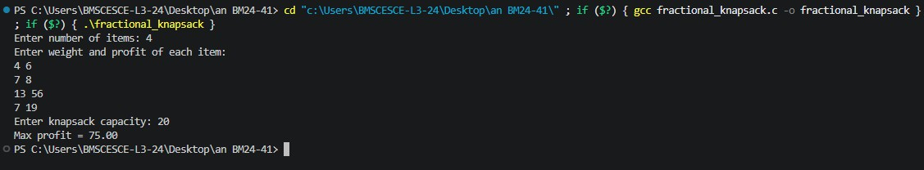

Lab program 10:
From a given vertex in a weighted connected graph, find shortest paths to other vertices using Dijkstra’s algorithm.

#include <stdio.h> #define INF 9999 int main() {
int n, src;
printf("Enter number of vertices: "); scanf("%d", &n);
int graph[n][n], dist[n], visited[n]; printf("Enter adjacency matrix:\n"); for (int i = 0; i < n; i++) {
for (int j = 0; j < n; j++) { scanf("%d", &graph[i][j]);
}
}
printf("Enter source: "); scanf("%d", &src);
for (int i = 0; i < n; i++) { dist[i] = INF;
visited[i] = 0;
}
dist[src] = 0;
for (int i = 0; i < n - 1; i++) { int min = INF, u = -1;
for (int j = 0; j < n; j++) {
if (!visited[j] && dist[j] < min) { min = dist[j];
u = j;
}
}
if (u == -1) break; visited[u] = 1;
for (int j = 0; j < n; j++) {
if (graph[u][j] && !visited[j] && dist[u] + graph[u][j] < dist[j]) {
dist[j] = dist[u] + graph[u][j];
}
}

}
printf("Shortest distances:\n"); for (int i = 0; i < n; i++) {
printf("%d -> %d = %d\n", src, i, dist[i]);
}
return 0;
}

Output:

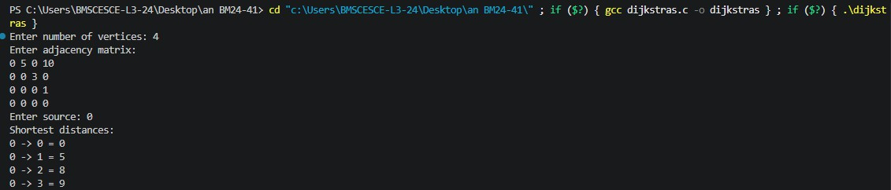

Lab program 11:
Implement “N-Queens Problem” using Backtracking.

#include <stdio.h> #include <stdlib.h> #define MAX 20 int board[MAX], n;
int solutionCount = 0; int place(int row)
{
int i;
for(i = 1; i < row; i++)
{
if(board[i] == board[row] ||
abs(board[i] - board[row]) == abs(i - row))
{
return 0;
}
}
return 1;
}
void printSolution()
{
int i, j; solutionCount++;
printf("\nSolution %d:\n\n", solutionCount); for(i = 1; i <= n; i++)
{
for(j = 1; j <= n; j++)
{
if(board[i] == j) printf(" 1 ");
else
printf(" 0 ");
}
printf("\n");
}
}

void queen(int row)
{
int col;
for(col = 1; col <= n; col++)
{
board[row] = col; if(place(row))
{
if(row == n)
{
printSolution();
}
else
{
queen(row + 1);
}
}
}
}
int main()
{
printf("Enter number of queens: "); scanf("%d", &n);
queen(1);
printf("\nTotal Possible Solutions = %d\n", solutionCount); return 0;
}

Output:
